Report Front Sheet
Molecular Biology, Master Course
EXPERIMENTAL CELL BIOLOGY
Name of Experiment: |  | Exercise 4 week 1: Cell Cycle Analysis and Hoechst 33342 / Alamar Blue 96 well assays
Date for performance of experiment: |  |  |  |  |  | 15-06-2026 -- 19-06-2026
Teacher: | Ole Vang
Team | Green |  |  |  |  | Group Number: |  |  | 3
Experiment was performed by: |  |  | Lars Eivind Bustamante Christoffersen, Line Babette Trust, Andreas Giovanni Kristian Frilev Olesen
 |  |  | Names and signatures
- - - - - - - - - - - - - - - - - - - - - - - - - - - - - - - - - - - - - - - - - - - - - - - - - - - - - - - - - - - - - - - - - - - - -
Date(s) for handing in the report to the teacher:
Date for 1. time |  |  |  | Date for 2. time |  |  |  | Date for 3. Time
Teacher comments:
Report approved by teacher:
 |  |  |  |  |  |  | Signature |  |  | Date
This is the front page for the reports and has to be attached to the report. The original front page should be attached when a revised report is handed in.
The Biology Study Board
Exercise 2a Cell Cycle Analysis









Cell cycle analysis (2a):
Introduction: In this experiment, flow cytometry-based cell cycle analysis were used to investigate the effects of sodium butyrate (NaBu) on DLD-1 cell lines. Flow cytometry with propidium iodide (PI) staining allows quantification of cellular DNA content and determination of the distribution of cells in the G1, S, and G2/M phases of the cell cycle. Changes in cell cycle distribution can indicate altered proliferation or cell cycle arrest induced by experimental treatments.

Methods: DLD-1 and Caco-2 cells were seeded in T75 flasks and cultured for 24 h before treatment. Cells were exposed to either PBS control or 10 mM sodium butyrate (NaBu) for 48 hours..
Following treatment, cells were harvested by trypsinization, washed in PBS-EB, and fixed in 70% ethanol. Fixed cells were stained with propidium iodide and RNase A before analysis by flow cytometry. Data acquisition and analysis were performed using the free software Floreada.io with cell cycle analysis based on the Watson pragmatic model. Doublets were excluded by gating on FSC-A versus FSC-H plots. Cell cycle distributions analysed based on DNA content histograms.

Results: Single-cell populations gated from FSC-A versus FSC-H. The same gate was applied to all samples to minimize analysis bias, gating is seen in figure 1 for PBS-treatment and figure 2 for NaBu-treatment.

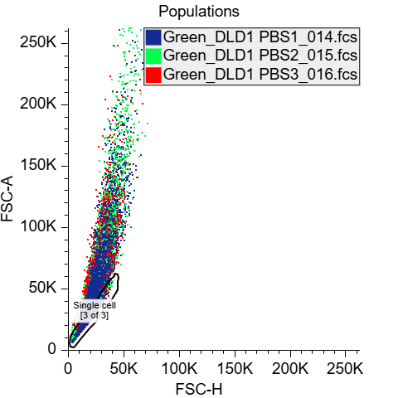 | 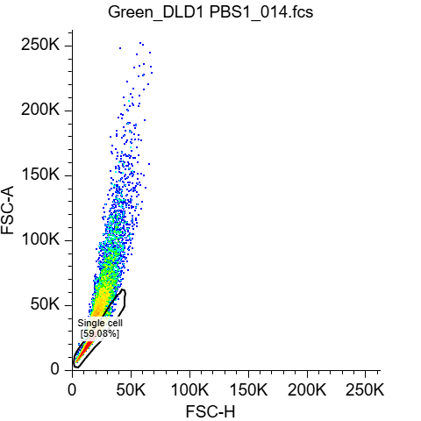
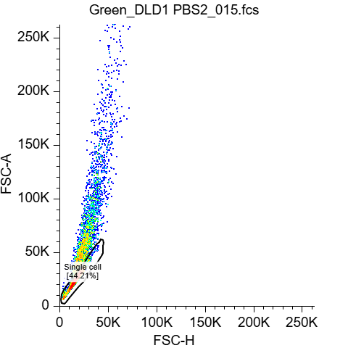 | 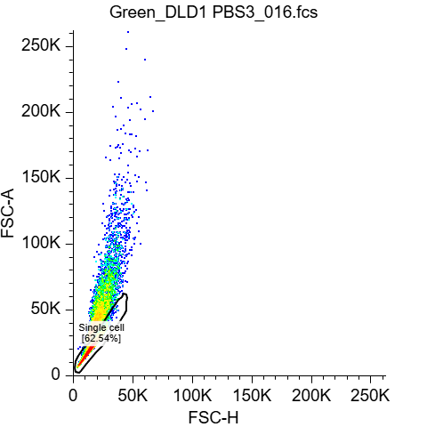
Figure 1. FSC-A plotted against FSC-H for all samples of PBS, and each sample individually. The same gating for single cell, were used for all replicates, to minimize bias. Eventcounts for PBS1= 10.000, PBS2= 3739 PBS2: 10.000 before gating.
After gating is applied PBS1= 5908, PBS2= 1653, PBS3= 6254.
Data acquisition and analysis were performed using the free software Floreada.io.

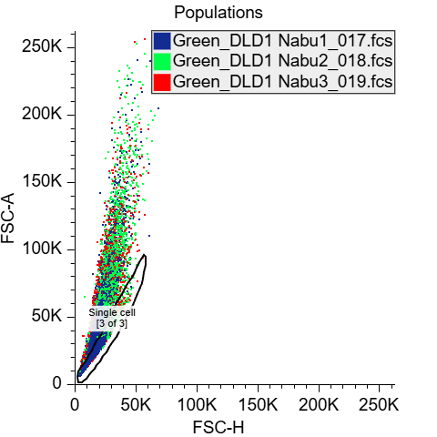 | 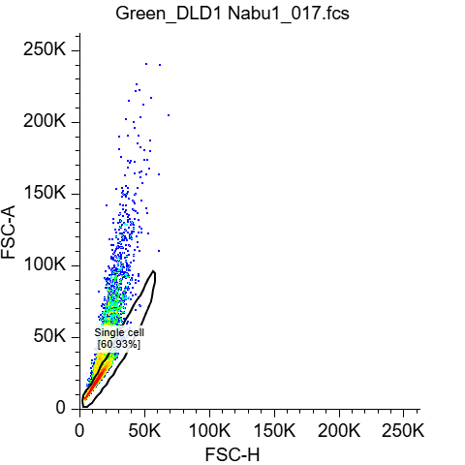
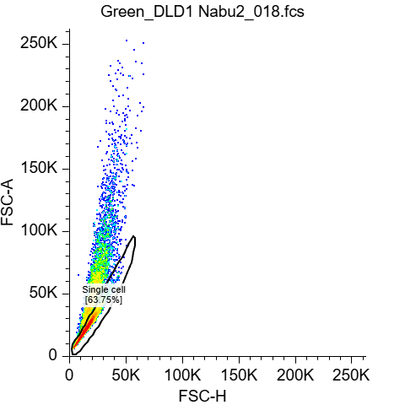 | 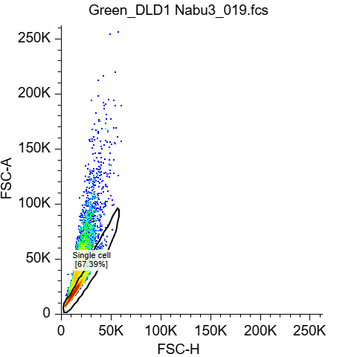
Figure 2. FSC-A plotted against FSC-H for all samples of NaBu, and each sample individually. The same gating for single cell, were used for all replicates, to minimize bias. Eventcounts for NaBu1= 5076, NaBu2: 10.000, NaBu3=10.000 before gating.
After gating is applied NaBu1= 3093, NaBu2= 6375, NaBu3= 6739
Data acquisition and analysis were performed using the free software Floreada.io.

As observed in figure 3, the PBS-treated control cells showed a relatively similar cell cycle distribution across all three replicates. Approximately 33% of cells were present in G1 phase, 50–52% in S phase, and 15–18% in G2 phase. Treatment with NaBu resulted in a marked change in cell cycle distribution. The percentage of cells in G2 phase increased from approximately 16–17% in control cells to 42–43% following treatment. Simultaneously, the proportion of cells in S phase decreased from approximately 50–52% to 23%. Only minor changes were observed in the G1 population. Summary of percentage is shown in table 1 below.

PBS | NaBu
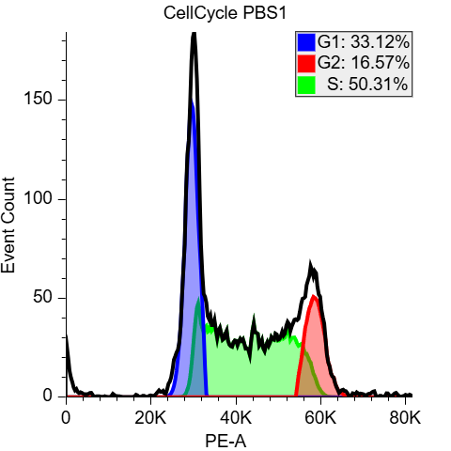 | 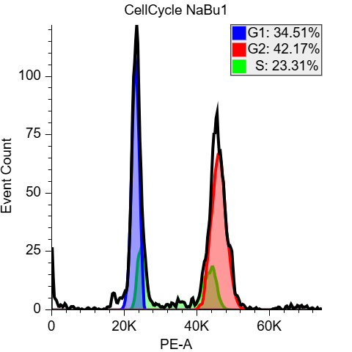
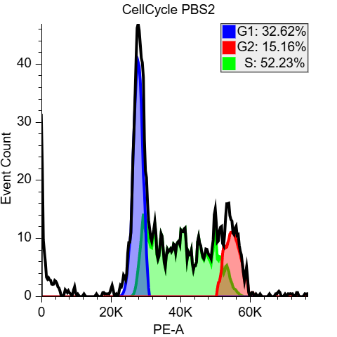 | 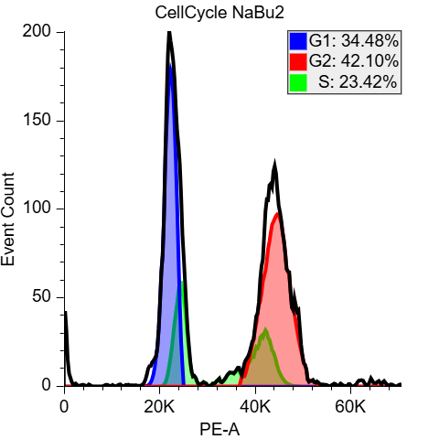
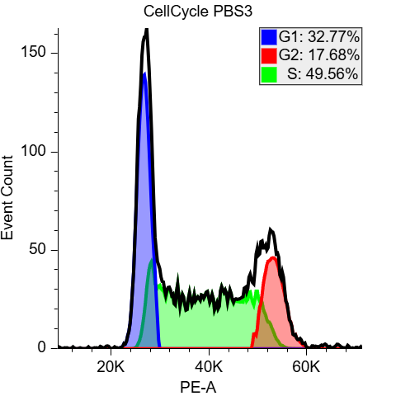 | 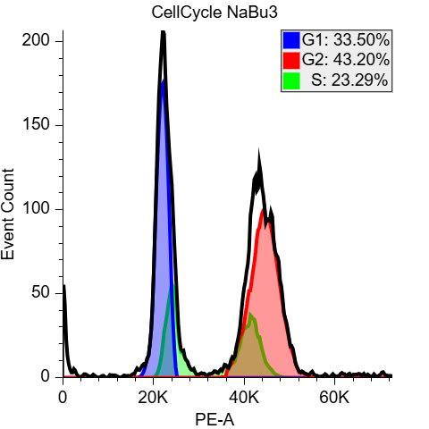
Figure 3. Cell cycle analysis for each sample (PBS1, PBS2, PBS3, NaBu1, NaBu2, and NaBu3) after gating for single cell were applied. Eventcounts for PBS1= 5908, PBS2= 1653, PBS3= 6254, NaBu1= 3093, NaBu2= 6375, NaBu3= 6739.
Data acquisition and analysis were performed using the free software Floreada.io with Cell Cycle analysis based on the Watson pragmatic model.

 | G1 | G2 | S
PBS1 | 33,12% | 16,57% | 50,31%
PBS2 | 32,62% | 15,16% | 52,23%
PBS3 | 32,77% | 17,68% | 49,56%
 | G1 | G2 | S
NaBu1 | 34,51% | 42,17% | 23,31%
NaBu2 | 34,48% | 42,10% | 23,42%
NaBu3 | 33,50% | 43,20% | 23,29%

Table 1.PE-I based Cell cycle distribution of DLD-1 cells with PBS as control treatment and 10 mM Nabu. Cell cycle distribution was analyzed by flow cytometry and the percentages of cells in G1-,S-, and G2/M -cell cycle phases is shown.

Figure 4. PE-I based Cell cycle distribution of DLD-1 cells with PBS as control treatment and 10 mM Nabu. Cell cycle distribution was analyzed by flow cytometry and the percentages of cells in G1-,S-, and G2/M -cell cycle phases is shown. We are short on time and will insert ± SEM in the final report.

Discussion: Cell cycle analysis estimates proliferation by determining the percentage of cells in G0/G1, S, and G2/M phases. This provides information about the distribution of cells across different phases of the cell cycle, and not just whether the cells are proliferating, which is an advantage because it can identify cell cycle arrest of delays caused by exposure of chemicals, drugs etc. Another advantage of the cell cycle analysis is also that it analyses a large number of cells. Some of the drawback from cell cycle analysis is that it measures DNA content rather than DNA synthesis directly, which makes it an indirect measurement of proliferation, and it cannot distinguish between cells that are actively progressing through the cell cycle and cells that are arrested in a cell cycle phase.
It provides a insight into the cell population at one time (snapshot), so if you want to measure at different timepoint, new experiments should be initiated with different time points for harvesting. Furthermore, cells with abnormal DNA content can complicate the interpretation.
Bromodeoxyuridine (BrdU) incorporation directly measures DNA synthesis because BrdU is incorporated into newly replicated DNA during S phase of the cell cycle. Therefore, it could be interpreted as a more direct measurement of proliferating cells. However, BrdU assays require additional staining procedures, DNA denaturation to expose incorporated BrdU, and may affect cell physiology. Unlike cell cycle analysis, BrdU labeling specifically identifies cells actively synthesizing DNA.
Cell cycle analysis provides broader information about cell cycle dynamics and checkpoints, whereas BrdU incorporation offers direct measurement of DNA replication and cell proliferation.

Exercise 2b Hoechst 33342 / Alamar Blue 96 well assays





Hoechst 33342 / Alamar Blue 96 well assays (2b):
Introduction: In this experiment, fluorescence-based viability assays were used to investigate the effects of sodium butyrate (NaBu) on DLD-1 and Caco-2 cell lines. Cell viability and metabolic activity were assessed using the Hoechst 33342 and resazurin (Alamar Blue) assays. Hoechst 33342 binds DNA and provides an estimate of relative cell number, whereas resazurin is converted to a fluorescent product by metabolically active cells and reflects cellular metabolic activity.
Methods: DLD-1 and Caco-2 cells were seeded in 96-well plates at 10,000 cells per well. Cells were treated with increasing concentrations of NaBu (0.5, 1, and 5 mM). For viability measurements, cells were incubated with Hoechst 33342 (5 µg/mL) and resazurin (25 µg/mL). Resazurin fluorescence was measured first to estimate metabolic activity. Cells were subsequently washed and Hoechst fluorescence was measured to estimate relative cell number. Results were normalized to untreated control cells.
Results: The effect of NaBu on cell number was assessed using the Hoechst 33342 assay, while cellular metabolic activity was evaluated using the resazurin assay.
For DLD-1 cell line NaBu treatment reduced both cell number and metabolic activity in a concentration-dependent manner as seen on figure 5. Relative cell number measured by Hoechst fluorescence decreased from 100% in the control group to approximately 88%, 67%, and 26% following treatment with 0.5, 1, and 5 mM NaBu, respectively.
Similarly, resazurin fluorescence decreased to approximately 87%, 65%, and 23% of control values at 0.5, 1, and 5 mM NaBu, respectively. The reduction in metabolic activity closely followed the reduction in cell number.

Figure 5. need some text
For teacher: ± SEM is calculated but it is very small and diffucult to see on the graphs

Caco-2 cells appeared less sensitive to NaBu treatment than DLD-1 cells. At 0.5 and 1 mM NaBu, Hoechst and resazurin signals remained close to control levels. At 5 mM NaBu, however, cell number decreased to approximately 61% of control and metabolic activity decreased to approximately 57% of control.

Figure 6. need some text
For teacher: ± SEM is calculated but it is very small and diffucult to see on the graphs

Discussion: The Hoechst 33342 assay demonstrated that sodium butyrate reduced the relative number of viable cells in both cell lines. However, the effect was substantially greater in DLD-1 cells than in Caco-2 cells. In DLD-1 cells, cell number decreased progressively with increasing NaBu concentration, reaching approximately 26% of control at 5 mM NaBu. In contrast, Caco-2 cells were less affected at lower concentrations and retained approximately 61% of control cell number at 5 mM NaBu.
The resazurin assay showed a similar concentration-dependent decrease in metabolic activity. The decrease in resazurin fluorescence closely matched the decrease in Hoechst fluorescence.

The flow cytometry results indicated that the NaBu treatment caused an accumulation in the proportion of cells in the G2 phase of the cell cycle and a corresponding decrease in the S-phase population. This indicates that NaBu induced cell cycle arrest, which likely contributed to the reduction in cell proliferation observed in the viability assays.
Comparison with results from the remaining groups and between the two cell lines using a larger dataset could not be performed at the time of writing because these data were not yet available. To be continued …

